Climate Emergency Strategy
  - July 2021

Contents
Document Control 3
Introduction 4
Background 4
What is climate change? 4
How are humans changing the climate? 4
How fast is the temperature rising? 5
Action on Climate Change 5
Current Position 8
Aim: 8
Objectives: 8
Current Emissions Profile – The Council (organisation) 9
Annual Greenhouse Gas Emission to the end March 2021 9
Current Emissions Profile – The Borough of South Ribble 10
Data and technical guidance used to establish the 1990 baseline 11
COVID-19 (Coronavirus) 14
Goals 16
Towards 2030 – The Way forward 17
Climate Carbon Wedge 18
Transport 19
Energy and the Built Environment 21
Consumption 23
Waste and Water 24
Carbon Offsetting 25
Resilience - preparing for the consequences of climate change within the Borough 25
Infectious diseases 25
Food safety 26
Flooding 27
Planning 27
Next Steps 29
Performance / Monitoring 31
Resources 31
References check and re-order at the end 32
Glossary 34
Appendices 36
Appendix 1 - SRBC climate emergency task group scope 36
Appendix 2 - SRBC Notice of motion July 2019 45
Appendix 3 - Revised One Carbon World Report for the period 2018 - 2019 48
Appendix 4 – Annual greenhouse Gas Report to end March 2021 49
Appendix 5 – Actions arising from the Air Quality Action Plan 2018 59

Table of Figures
Figure 1 – Global temperature change from 1850 – 2018, compared to the 1961 – 1990 average temperature (1) 5
Figure 2 – Changing UK temperatures 8
Figure 3 - South Ribble Borough Council CO2 emissions estimates 2005 – 2017 (ktCO2) – Grand Total data (14) 11
Figure 4 - borough CO2 emissions by subsector (tCO2e) (29) 12
Figure 5- Eurostat Greenhouse Gas Emissions for the UK, base year 1990 – Index (1990 = 100%) (15) 13
Figure 6- Estimated carbon emissions data for the Borough of South Ribble from 1990 – 2017 (ktCO2) 14
Figure 7 - Emissions inventory for the South Ribble borough 15
Figure 8 - 2020-2030 trajectories 18
Figure 9 - Carbon footprint reduction options for 2020 – 2030 30

Document Control

Publication Date | July 2021
Related Documents | SRBC Climate Emergency Declaration July 2019  SRBC Climate Emergency Strategy 2020  All related documents may be viewed via the SRBC website  South Ribble Borough Council
Owner (Department) | Environmental Health
Author (Team) | Environmental Health / Climate Emergency Task Group

Review of Strategy
Review Date | July 2022
Version | 2.0

Introduction

In 2019, South Ribble Borough Council declared a climate emergency, pledging to work to make the Borough carbon neutral by 2030.
This strategy summarises the global, national and local needs for such action, and how the Council will be acting during the next decade to deliver on this pledge.
The climate emergency strategy was first published in 2020, this edition forms the first annual update.

Background

What is climate change?
Climate change is the long-term shift in average weather patterns across the world. Since the mid-1800s, humans have contributed to the release of carbon dioxide and other greenhouse gases into the air. This causes global temperatures to rise, resulting in long- term changes to the climate. (16)

Figure 1 – Global temperature change from 1850 – 2018, compared to the 1961 – 1990 average temperature (1)

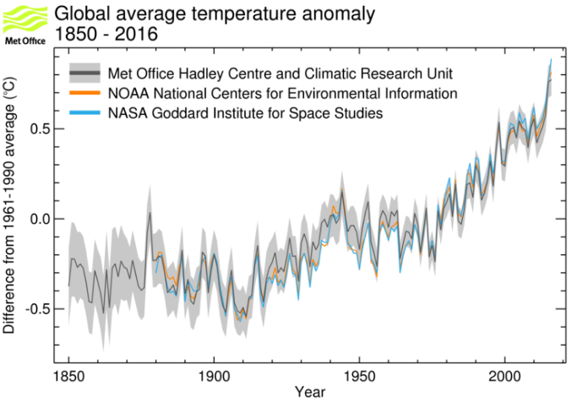

How are humans changing the climate?

In the 11,000 years before the Industrial Revolution, the average temperature across the world was stable at around 14°C. The Industrial Revolution began in the mid-1800s when humans began to burn fossil fuels such as coal, oil, and gas for fuel. (16)
Burning fossil fuels produces energy, but also releases greenhouse gases such as carbon dioxide, methane, and nitrous monoxide into the air. Over time, large quantities of these gases have built up in the atmosphere.
Once in the atmosphere, greenhouse gases such as carbon dioxide form a 'blanket' around the planet. This blanket traps the heat from the sun and causes the earth to heat up.
Evidence has shown that the high levels of greenhouse gases in the atmosphere are the leading cause of increasing global temperatures.
This effect was noticed as far back as the 1980s. In 1988, the International Panel on Climate Change (IPCC) was set up to provide governments with information to tackle climate change.
In their most recent report, the IPCC states that human activity is 'extremely likely' to be the main cause of climate change. (17)

How fast is the temperature rising?

Since the Industrial Revolution, the average temperature of the planet has risen by around 1°C. This is a rapid change in terms of our global climate system. Previously, natural global changes are understood to have happened over much longer periods of time. (It is also important to remember that the world is not warming evenly, so the temperature increase is higher than 1°C in some countries. (16))

Action on Climate Change

At the Paris climate conference (COP21) in December 2015, 195 countries adopted the first- ever universal global climate deal that is due to come into force in 2020. The agreement sets out a global action plan to put the world on track to avoid dangerous climate change by limiting global warming to well below 2°C above pre-industrial levels and pursue efforts towards limiting to 1.5°C.
Then, in 2018, the Intergovernmental Panel on Climate Change (IPCC) published a report which advised that global warming must be limited to 1.5°C, as opposed to the previous target of 2°C. The IPCC’s review of over 6,000 sources of evidence found that, with a rise of 1.5°C, there would be risks to health, livelihoods, food security, water supply, human security and economic growth. A rise to 2°C would be even more catastrophic. It warned that there are 12 years within which to take the serious action required to avert this crisis and avoid the worst impacts.
Nationally, the Climate Change Act 2008 introduced the UK’s first legally binding target for 2050 to reduce greenhouse gas emissions by at least 80% compared to 1990 levels. Then, on 27 June 2019 the UK government amended the Climate Change Act to set a legally binding target to achieve net zero greenhouse gas emissions from across the UK economy by 2050. (5)
However, despite these actions, the UK is already being affected by rising temperatures. The most recent decade (2008-2017) has been on average 0.8 °C warmer than the 1961- 1990 average. All ten of the warmest years in the UK have occurred since 1990 with the nine warmest occurring since 2002.
The image below, produced by the Met Office, provides a very clear representation of the changing temperatures within the UK.

Figure 2 – Changing UK temperatures
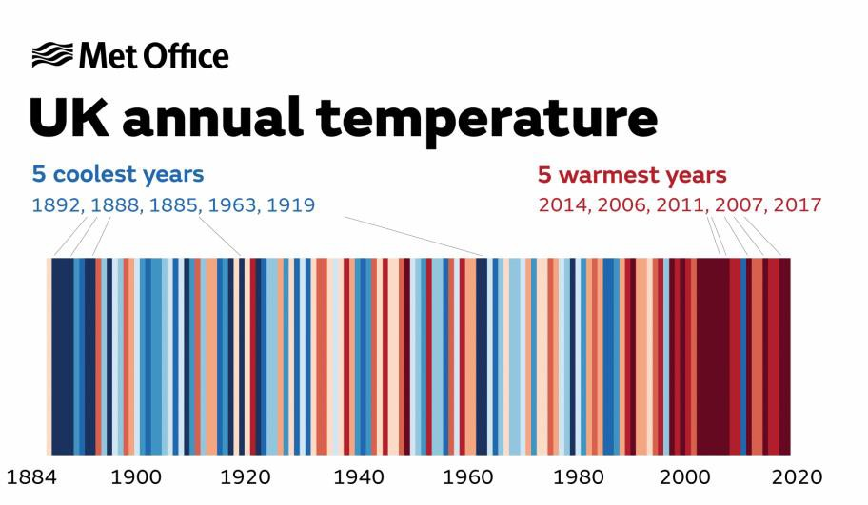
(12)

And internationally, with warming at the Earth’s surface, many other changes in the climate are occurring:
- Warming oceans
- Melting polar ice and glaciers
- Rising sea levels
- More extreme weather events

It is clear that ‘business as usual’ is not an option. Change is required.

In July 2019, acknowledging the change required, South Ribble Borough Council declared a climate emergency and set a goal to become Carbon neutral by 2030 (2)

The Council committed to the formation of a Working Group on the Climate Emergency, to:
- Incorporate the Council’s existing Air Quality Action Plan into its wider plans
- Devise and propose further measures in pursuit of its goals
- Monitor progress towards its goals
- Report back to full Council at least four times per year on its progress in achieving its goals

Current Position

Further to the Climate Emergency declaration in July 2019 a Climate Emergency Task Group was been formed, consisting (at the time) of a minimum of:
- Cabinet Member responsible for the Environment (in the Chair)
- Chairs of each Neighbourhood Forum
- Representatives of each political group represented on the council (2 Labour Members, 1 Liberal Democrat Member. 2 Conservative Members)
- Air Quality Lead
- Such other Members, including co-opted members, as the working group shall consider appropriate

The climate emergency task group has agreed the following aim and objectives –

Aim:
To achieve carbon neutrality for the borough of South Ribble by 2030, taking account of any carbon offsetting identified.

Objectives:
To carry out an assessment of current activities, including estimating the current Carbon Footprint of South Ribble.

To research best practice and look for innovative new approaches to reducing carbon emissions, carbon off setting and climate mitigation.

To produce a Climate Emergency Strategy and way forward for Council to consider.

To include those elements contained within the Greenhouse Gas Protocol defined as Scope 1 and Scope 2 emissions. Direct emissions shall be taken as including fuel (energy), vehicles, farming, quarrying, waste produced and deposited within the borough from Domestic, Commercial, Industrial, Educational, Farming and leisure activities. It does not include those emissions generated by vehicles travelling through the borough, i.e. on motorways or by railway.

To define all emissions and reductions against a base year of 1990.

Current Emissions Profile – The Council (organisation)

In 2020 the Council employed One Carbon World, a resource partner of the United nations Climate Neutral Now initiative, to quantify the Council’s carbon emissions for the period 2018-2019 and identify possible improvements. The findings of One Carbon World were published as an Appendix to the 2020 version of the Council’s climate emergency strategy.

Since this time the Council has undertaken its own annual carbon / Greenhouse Gas (GHG) calculations for the years 2019 – 2020, and 2020-2021. As part of this process a review was conducted on the findings provided by One carbon World. This review identified errors within the calculations for the period of 2018-2019, which meant that the Council reported an artificially high carbon emission declaration for this period. One Carbon World have now issued a corrected report, which is included as Appendix 3.

The methodology for the annual GHG calculations are those provided by the Department for Business, Energy and Industrial Strategy (BEIS). This standard national approach allows the Council to benchmark against others and share best practice and improvements amongst similar Authorities and other organisations.

Annual Greenhouse Gas Emission to the end March 2021

The total carbon footprint for 2020 – 2021 was 2,450,179.48 kgCO2e. (CO2e = Greenhouse Gas equivalent emissions)
The most significant sources of CO2e emissions for this period were identified as fuel use, primarily natural gas, but also diesel and petrol use in Council fleet vehicles. These emission sources are to be prioritised as part of the Council’s climate Emergency action plan, which details those actions the Council will be taking as an organisation, to reach the goal of carbon neutrality by 2030.

A full breakdown of the annual emissions is provided within the Annual Greenhouse Gas Report 2021, included as Appendix 4.

Current Emissions Profile – The Borough of South Ribble

The UK Office for National Statistics (ONS) has published UK local authority estimates of carbon dioxide emissions statistics from 2005 to 2017 (14). Chart 1 below shows the ONS estimated figures for the Borough of South Ribble, from 2005 to 2017

Figure 3 - South Ribble Borough Council CO2 emissions estimates 2005 – 2017 (ktCO2) – Grand Total data (14)
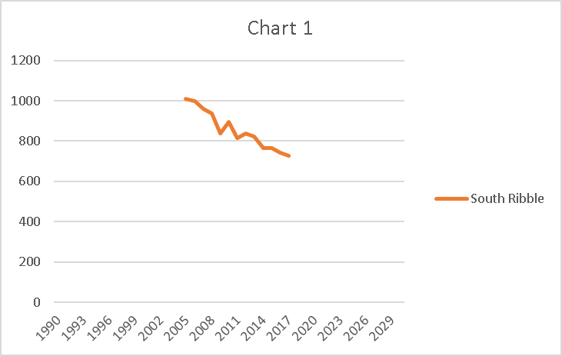

Data source – Gov.uk https://www.gov.uk/government/statistics/uk-local-authority-and-regional-carbon-dioxide- emissions-national-statistics-2005-to-2017,
ktCO2 = Kilotonnes Carbon Dioxide

This total value can be broken down (figure **) to show those sectors making the greatest contribution to emissions across the borough.

Figure 4 - borough CO2 emissions by subsector (tCO2e) (29)

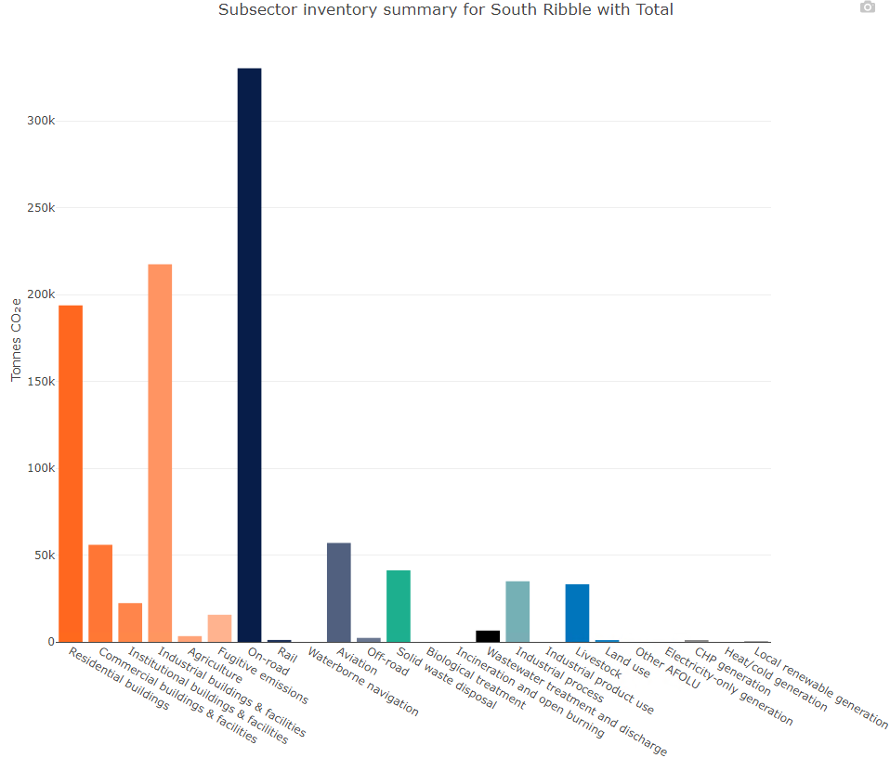

Data and technical guidance used to establish the 1990 baseline

As Borough specific data from 1990 to 2005 is not available, it has been necessary to estimate the data for the Borough for this period. So, whilst data for the Borough was not available for 1990 – 2005, national data was able to be obtained from Eurostat, a directorate-general of the European Commission (15). This data is shown in Chart 2 below.

Figure 5- Eurostat Greenhouse Gas Emissions for the UK, base year 1990 – Index (1990 = 100%) (15)

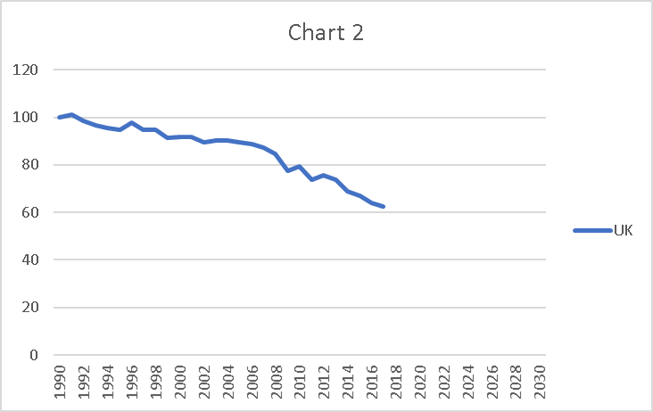

Data source – Eurostat. https://ec.europa.eu/eurostat/databrowser/view/t2020_30/default/line?lang=en

The Eurostat data used to produce Graph 2 shows trends in total man-made emissions of the of greenhouse gases (based on Kyoto protocol) within the UK. It presents annual total emissions in relation to 1990 emissions as a percentage.
Note - The Kyoto protocol includes the ‘Kyoto basket’ of greenhouse gases - carbon dioxide (CO2), methane (CH4), nitrous oxide (N2O), (hydrofluorocarbons (HFCs), perfluorocarbons (PFCs), nitrogen trifluoride (NF3) and sulphur hexafluoride (SF6). These gases are aggregated into a single unit using gas-specific global warming potential (GWP) factors. The aggregated greenhouse gas emissions are expressed in units of CO2 equivalents.

Chart 3, below, uses the UK trends within Chart 2 to estimate data and trends for the Borough of South Ribble, providing an estimated baseline of 1990 and showing an estimated trend from 1990 -2005, using a method of linear approximation based on the ONS published estimates from 2005 – 2017.

Figure 6- Estimated carbon emissions data for the Borough of South Ribble from 1990 – 2017 (ktCO2)

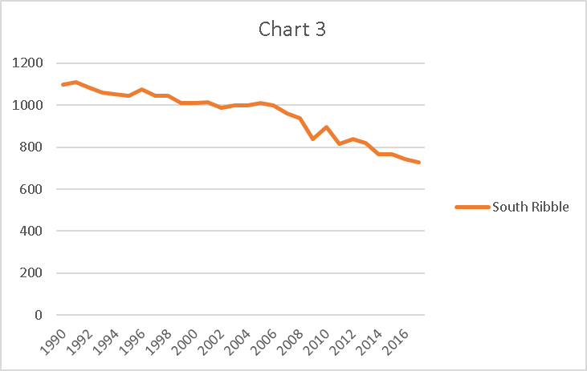

Note – this chart is based on estimates using national data. It is for illustrative purposes and should not be regarded as actual measurements for the Borough.
In considering those actions within the Council’s action plan, and their prioritisation, it has also been necessary to consider how these total figures break down into emission scopes, and further subsections beyond.

Figure 7, below, illustrates the emissions contributions from various sectors across the borough (29)

Figure 7 - Emissions inventory for the South Ribble borough

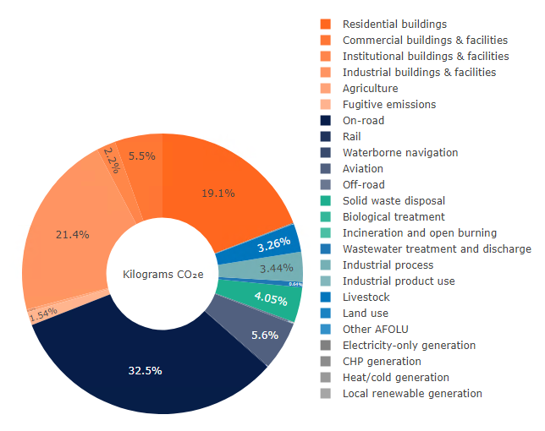
Details as to how these areas will be addressed is included within the Council’s climate emergency action plan.

COVID-19 (Coronavirus)

In December 2019 the world saw the first reported cases of COVID-19, also known as Coronavirus. In the following months we witnessed the development of a global pandemic as the World Health Organisation and individual nations reacted to the surge in cases around the world.

The COVID-19 pandemic has been and will continue to be a life changing, traumatic event for many people around the world. The statements below are in no way intended to detract from that.

Environmentally, the pandemic has brought both positive and negative effects, as summarised in the table below (27)

Positive Impacts | Negative Impacts
Increased outdoor air quality | Increased ecological risk to natural ecosystems due to use of disinfectants
Decrease in energy consumption and GHG emissions | Increased medical waste
Increase in surface water quality | Increased disinfection routines with chemical substances in household and outdoor environments

In June 2020 the DEFRA Air Quality Expert Group (AQEG) published estimations of changes in air pollution emissions, concentrations and exposure during the pandemic within the UK (28). The findings at that time were that emissions of pollutants related to transport were markedly decreased, particularly relating to nitrogen oxides (NOx) in urban environments, with typical reductions of 30 – 40%. However, the report suggests that for some people, increased time spent on activities in the home such as cooking and cleaning may have increased emissions and concentrations of pollutants such as PM2.5 and Volatile Organic Compounds.

Also in 2020 the Committee on Climate Change (CCC) has written to the UK Government advising on how the nation can emerge from the pandemic whilst delivering a stronger and cleaner economy. (25). These recommendations include –
Build new homes that are fit for the future, Scale up housing retrofits,
Invest in low-carbon, resilient infrastructure such as improved broadband instead of new roads,
Make it easy for people to work remotely, walk and cycle, Expand tree planting,
Ensuring the benefits of climate change are shared widely and that actions taken do not burden those who are least able to pay
The CCC Chairman, Lord Deben, said ‘ The COVID-19 crisis has shown the importance of planning well for the risks the country faces. Recovery means investing in new jobs, cleaner air and improved health. The actions needed to tackle climate change are central to rebuilding our economy. The Government must prioritise actions that reduce climate risks and avoid measures that lock-in higher emissions’ (25)
These themes have been used to influence the Council’s climate emergency action plan,

Goals

In July 2019 South Ribble Borough Council declared a climate emergency and set a goal to become Carbon neutral by 2030
Within the 2019 climate emergency Council declaration, the statement is made –

‘This Council declares that the effect of climate change within the borough poses an immediate danger to the health and well-being of our residents and therefore proclaims a Climate Emergency with immediate effect.
To combat this threat, the borough sets a goal of rendering the borough carbon neutral by the year 2030.’

A full copy of the Council motion is detailed as Appendix 2

Towards 2030 – The Way forward

This strategy encompasses two broad themes –

Carbon Reduction Measures - how the Council intends to progress towards the 2030 carbon neutral goal, and

Resilience - preparing for the consequences of changing climate within the Borough

Carbon reduction measures - Progressing towards the 2030 Carbon Neutral aim
Had the Council elected not to declare a climate emergency, and continue with ‘business as usual’ the Chart 4 below shows the estimated carbon emissions for the Borough to 2030.

However, having declared a climate emergency, and committed to the goal of carbon neutrality for the Borough by 2030, Chart 4 also illustrates the revised trajectory that the Council has elected to aim for.
Figure 8 - 2020-2030 trajectories
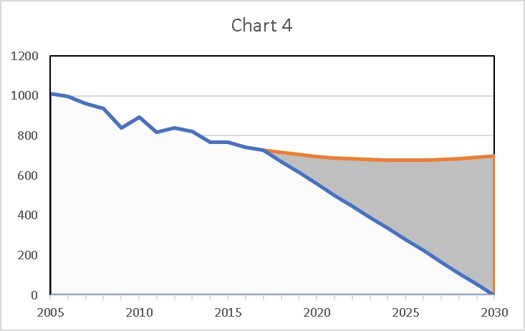

The upper, orange trajectory to 2030 shows an estimated business as usual prediction if no corrective action was to be taken *
*These future estimates have been calculated using historic data for the Borough and a quadratic regression formula to predict future carbon emissions

The lower, blue trajectory from 2017 – 2030 illustrates the path that the Council has chosen to pursue in declaring a climate emergency.

The shaded area, in between the two trajectories, is known as the Carbon Wedge.

Climate Carbon Wedge

The climate carbon wedge concept was introduced by two Princeton professors, Rob Socolow and Stephen Pacala. These wedges describe a range of technologies and choices about how we act, that when taken together form wedges against increasing carbon emissions.

What does the climate carbon wedge contain? In essence, this is the sum of all of the changes required during the next decade to achieve the aim of carbon neutrality for the Borough by 2030.

There may be many ways to achieve the desired outcome, many of which may not be in the direct control of the Council for example national Government environmental levies or incentives. In addition, circumstances will change as we proceed through the coming decade to 2030. It is therefore proposed to review this strategy each year to document progress and ensure continuing development, in line with national requirements and emerging technology.

The carbon reduction plan can be split into 5 main categories –
- Transport
- Energy and the Built Environment
- Waste and Water
- Consumption
- Off-setting

Transport

The World Health organisation has stated that the transport sector is the fastest growing contributor to climate emissions. Growth in energy use is higher for the transport sector than any other end-use sector. The main drivers of global transport energy growth are land transport, mostly light-duty vehicles, such as cars, as well as freight transport. (23)

Transport’s contribution to climate change include:

  - long-lived carbon dioxide (CO2) emissions and;
  - short-lived black carbon generated primarily by diesel vehicles.

CO2 emissions
Transport accounted for about 23% of global carbon dioxide emissions in 2010 and 27% of end-use energy emissions with urban transport accounting for about 40% of end-use energy consumption. Carbon dioxide persists in the atmosphere for over a century, with long-term warming effects (23)

Short-lived climate pollutants (SLCPs)
Black carbon, a short-lived climate pollutant, is the second highest contributor to global warming after CO2. Black carbon has a warming effect many times more powerful than carbon dioxide, but it persists in the atmosphere for only a few weeks – so measures to reduce black carbon can also have an immediate effect on slowing the pace of climate change.

Diesel transport is one of the world’s major sources of black carbon (along with household biomass cookstoves). Not only does black carbon have a significant warming effect, but it is also a major component of particulate matter, the air pollutant most closely associated with increased air-pollution related mortality and morbidity.

Ground-level ozone is another short-lived climate pollutant stimulated by transport pollution. Ozone is created by a mix of are pollutants, including oxides of nitrogen (NOx) produced by vehicle engines and methane emissions from other sources (e.g. landfills and animal waste). Ozone contributes to chronic respiratory diseases, particularly childhood asthma (23)

Ground-level ozone is another short-lived climate pollutant, stimulated by transport pollution. Ozone is created by a mix of air pollutants, including oxides of nitrogen (NOx) produced by vehicle engines (23)

The Council has already committed to many transport related actions with the Air Quality Action Plan 2018. This plan sits alongside the climate emergency strategy and action plan in detailing those works that the Council has committed to.

For ease, all of the actions from this plan (including many relating to the use of transport) have been included as Appendix 5.
In addition to the carbon reductions resulting from these actions, wider benefits of tackling transport emissions will include –
Improved air quality
The creation of safe areas for walking and cycling Healthier lifestyles resulting from active transport
Cost reductions associated with active transport and car sharing

Specific details of those actions that the Council will be taking, both as an employer and across the borough, are provided within the Climate Emergency Action Plan

Energy and the Built Environment
Currently, heating our homes, businesses and industry is responsible for a third of the UK’s greenhouse gas emissions. Decarbonisation of heat is recognised as one of the biggest challenges we face in meeting our climate targets (22)
Across the Borough, this is likely to form a significant challenge in the coming decade as we seek to promote and assist with the retro-fitting of the Borough’s existing privately owned housing stock. The housing within the Borough needs to become much more energy efficient in order to reduce the demand for energy.
The retro-fitting of existing housing stock is not a challenge unique to South Ribble, it is likely to be a national challenge within the coming decade. We will work with the national Government to identify ways of assisting residents in the process.
As an organisation we need to move to low carbon and / or renewable energy, and work with partners, businesses and our residents to encourage them to do the same.
In 2020, the Council was awarded a Public Sector Decarbonisation grant of £145,004. This will provide heat decarbonisation measures at the Civic Centre, Leyland including the installation of further solar PV panels, the installation of LED lighting, and the provision of an improved building management system, to allow for better energy control and efficiency within the building.
In addition, the Council is undertaking energy audits at 6 of its largest energy using buildings (Civic Centre, Moss Side Depot, Leyland Leisure Centre, Penwortham Leisure Centre, Bamber Bridge Leisure Centre and South Ribble Tennis and Fitness Centre) to determine those heat decarbonisation measures possible and provide an estimation of costs. This will include consideration of the building management systems on site and potential improvements.
The ultimate aim is to reduce the amount of gas and electricity used within the Borough to fuel commercial buildings and domestic properties.
To this end we will –
- Make best use of the planning processes to ensure all new housing stock is sustainable in design and affordable to heat
- Work with private landlords and housing associations to encourage best practice Retrofit a domestic property to use as a flagship of best practice for the Borough
- Continue to work to heat our own buildings with low carbon and / or renewable heating. All carbon based energy will be purchased vis green tariffs. The Council will seek to lead by example in its use of decarbonised energy
- Use LED lighting across the Council estate wherever possible
- Lobby national Government for the provision of mass affordable domestic retrofitting options Enforce private rented Minimum Efficiency Standards regulations
- Investigate Energy from Waste options
- Examine the possibility of large scale solar projects within the Borough
- Lobby national Government to ensure low carbon energy is available and affordable for everyone
- Seek funding opportunities for low carbon heating
- Promote national Government low carbon incentives within the Borough
- Make use of emerging technology to continually improve how we act as an organisation

- In addition to the carbon reductions resulting from these actions, wider benefits will include –
- Reduced energy bills for residents of the Borough
- Reduced energy bills for the Council
- Improving the condition of housing stock within the Borough Improving air quality by reducing emissions of NOx from gas boilers

Specific details of those actions that the Council will be taking, both as an employer and across the borough, are provided within the Climate Emergency Action Plan

Consumption

The goods we purchase and use may have emissions built in to their manufacture and transport. This is known as imported emissions. Examples may include food grown abroad, clothing manufactured abroad, mobile phones manufactured abroad, etc.

Our actions as consumers have a direct impact on the demand for products. So, whether we choose to repair instead of replace, choose plant based foods instead of meat, choose locally produced goods instead of imported, these choices have an impact upon imported emissions and potentially on waste too
If as an organisation and a Borough we are able to consume less, and consume more responsibly then this in turn will impact upon the imported emissions we cause and the amount of waste that we produce.

To this end we will –
- As an organisation we will seek to reduce our purchase and use of high energy commodities, for example single use plastics and meat based products.
- We will move to a more plant based menu for functions and meetings, and to purchase products made within the UK in order to reduce transport miles.
- We will also work with partners, businesses and residents to encourage responsible consumption and share best practice.
- Work with schools, colleges and partners to encourage more low carbon cooking and meals, and reduce food waste
- Work to improve the carbon emissions of Council events

Specific details of those actions that the Council will be taking, both as an employer and across the borough, are provided within the Climate Emergency Action Plan

Waste and Water

For many years the Council has worked to treat waste within the Borough responsibly and reduce the amount of waste going to landfill. We have an established domestic recycling scheme including the recycling of paper, cardboard, certain plastics and metals, glass and garden waste.
However, we recognise the importance of our role in working to reduce waste further and accept that actions will be needed to reduce the volumes of waste produced within the Borough, and then further reduce the proportion of that sent to landfill.
To this end we will –
- We will work with partners, businesses and residents to reduce the amount of waste
- produced, promote reuse and recycling of waste and examine means of using waste as an energy source.
- We will work with United Utilities, partners, businesses and residents to promote the responsible use of water throughout the Borough.
- As an organisation we will strive to lead by example, reporting our consumption all those measures we are taking to improve our performance.
- The Council has already committed to eliminating the use of Single Use Plastics by 2025. Investigate those improvements than can be made to our recycling service
- Work with residents to improve the percentage of waste recycled
- Make best use of new technology to continually improve waste collection and recycling services
- Continue with tree and hedge planting to slow the flow of rainfall over land, protect watercourses against erosion, protect watercourses against rising water temperatures and improve biodiversity

Specific details of those actions that the Council will be taking, both as an employer and across the borough, are provided within the Climate Emergency Action Plan

As a method of tackling all four of these categories above, the Council will seek to –

- Develop a climate emergency staff forum
- Develop a climate emergency citizen assembly for the Borough Make best use of emerging technology
- Make a greater difference by working in partnership with others Communicate our work internally and within our community Strive for continuous improvement and learn from best practice
- Adjust our approach in line with emerging evidence and technologies
- Specific details of those actions that the Council will be taking, both as an employer and across the borough, are provided within the Climate Emergency Action Plan

Carbon Offsetting

Carbon offsetting allows for organisations to compensate for their unavoidable carbon emissions with the use of projects that reduce an equivalent amount of emissions. The carbon emission projects can be internal to the organisation or procured from an external organisation. Examples of such projects could include tree planting and the installation of solar panels.

The Council already undertakes many carbon offsetting activities, which whilst not calculated as formal carbon offsetting, increase the capture of CO2 within the Borough.
Examples include the maintenance of parks, woodlands and open spaces within the Borough.
The Council has already committed to the planting of 110,000 trees within the Borough (one tree per resident) and the total planted to date is approximately 62,000.
Additional tree planting may be facilitated by use of the planning processes.
At this time the Council has not committed to the external purchase of carbon offsetting. However, as part of the contract with One Carbon World the Council received 300 carbon credits, which equates to the retirement of up to 300 tonnes equivalent of carbon

Resilience - preparing for the consequences of climate change within the Borough

South Ribble Borough Council, like many other Council’s, is already experiencing changes in weather patterns, including heat waves and flooding. Despite the actions being taken to reduce carbon emissions within the Borough it is necessary to accept that some changes affected by global warming are already upon us.

The Met Office have stated that ‘it is a cornerstone principle of resilience preparation that we plan for a wide range of possible future changes, in parallel with taking actions to reduce the likelihood of the worst scenario becoming reality’(24), so the Council must ensure it takes action to prepare for such changes, and reduce the effects of them where possible.

Infectious diseases
Global warming will affect the prevalence of infectious diseases (7) Altitudes that are currently too cool to sustain vectors (for example mosquitos) will become more conducive to them. Infections previously eradicated in the UK such as Malaria, dengue, plague, and viruses causing encephalitic syndromes are among the many diseases likely to return. With warmer and wetter weather conditions we may also see a rise in native pests such as rats and mice, and conditions which support the life cycle of non-native pest such as the Asian Hornet
Clearly, global warming will cause changes in the epidemiology of infectious diseases. The ability of our public health systems to react or adapt is dependent upon the magnitude and speed of the change. The outcome will also depend on our ability to recognize epidemics
early, to contain them effectively, to provide appropriate treatment, and to commit resources to prevention and research.
The Council’s Environmental Health service will continue to work with Public Health England, the Food Standards Agency, peers and businesses to investigate and control the spread of food and water related infectious diseases within the Borough
The Council’s Pest Control service will monitor changes in pest activity within the Borough, work with suppliers, peers, businesses and National Government to ensure the service remains fit for service in a changing environment. We will lobby Central Government as required to ensure suitable and safe products and methods are available to tackle the changing pest control challenges.

Food safety
The World Health Organisation (WHO) have stated that climate change is likely to have considerable impacts on food safety, both direct and indirect, placing public health at risk.
With changing rainfall patterns and increases in extreme weather events and the annual average temperature the WHO state that we will begin to face the impacts of climate change.
These impacts will affect the persistence and occurrence of food related bacteria, viruses, parasites, harmful algae, fungi and their vectors, and the patterns of their corresponding foodborne diseases and risk of toxic contamination.
The predicted climatic changes will have serious implications for the survival of our native pollinators therefore threatening the sustainability of our total food supply. There are already reports of the invasive Asian Hornet on the Channel Islands and in Southern England this year. This species has devastated bee hives in France and combined with the stress put on hives by increased temperatures and the use of pesticides this has significant implications for the security of our food supply.
Alongside these impacts, chemical residues of pesticides and veterinary medicines in plant and animal products will be affected by changes in pest activity. The risk of food contamination with heavy metals and persistent organic pollutants following changes in crop varieties cultivated, cultivation methods, soils, redistribution of sediments and long-range atmospheric transport, is increased because of climate changes.(6)

The Council’s Environmental Health service will continue to work with central Government, the Food Standards Agency, DEFRA, other partner organisations, laboratories, peers and businesses to continue to protect food safety within the Borough.
Whilst the Council’s food safety service is primarily concerned with the security and hygiene of the food manufactured and sold within the borough the service works collaboratively with the other local authorities within Lancashire to respond to consultations on future policies proposed by central government departments.
The Council’s Pest Control service will monitor changes in pest activity within the Borough, work with suppliers, peers, businesses and National Government to ensure the service remains fit for service in a changing environment. We will lobby Central Government as
required to ensure suitable and safe products and methods are available to tackle the changing pest control challenges.

Flooding
The Met Office have stated that the UK’s climate is becoming wetter. (8) For example, the highest rainfall totals over a five day period are 4% higher during the most recent decade (2008-2017) compared to 1961-1990. In addition, the amount of rain from extremely wet days has increased by 17% when comparing the same time periods.

More recently winter 2013/14 and winter 2015/16 have been two of the wettest on record, with widespread impacts during both seasons. A Met Office study has shown that an extended period of extreme winter rainfall in the UK, similar to that seen in winter 2013/14, is now about seven times more likely due to human-induced climate change.

December 2015 was the wettest December, and indeed any calendar month, in the UK series since 1910. Rainfall reached 2 to 4 times the average in the west and north, with severe flooding in Cumbria in particular. A recent study showed that the heavy rains associated with Storm Desmond has been made about 60% more likely due to human- induced climate change (26).

Met Office predictions suggest that summers may tend to become drier overall but when it does rain it will fall in heavier bursts, which has implications for flash flooding / surface water flooding

Flooding events are more difficult to understand as they depend not only on the amount and intensity of rainfall but local topography and geology

The Council will continue to work with the Environment Agency, United Utilities and Lancashire County Council to prevent flooding and react swiftly where it occurs.

Through their professional body, the CIEH, Environmental Health Officers are lobbying government regarding the numerous realities of climate change.

Planning
The Committee on Climate Change reports that there are plans for 1.5 million new UK homes by 2022 (9). It states that ‘these new homes must be built to be low-carbon, energy and water efficient and climate resilient. The costs of building to a specification that achieves the aims set out in this report are not prohibitive and getting design right from the outset is vastly cheaper than forcing retrofit later. From 2025 at the latest, no new homes should be connected to the gas grid. They should instead be heated through low carbon sources, have ultra-high levels of energy efficiency alongside appropriate ventilation and, where possible, be timber-framed. A statutory requirement for reducing overheating risks in new builds is needed, alongside more ambitious water efficiency standards, property-level flood protection in flood risk areas, and increasing requirements for greenspace and sustainable transport in planning and guidance.’

The Central Lancashire Authorities of Preston City, South Ribble and Chorley are undertaking a review of the development plan(s) for the area and are working towards the preparation of a Joint Local Plan for Central Lancashire. This will be a single Planning document containing the Council’s vision and objectives. It will set strategic and local development management policies and site allocations for future development across the three authorities. Once adopted, the Local Plan will guide the future growth and development in the Central Lancashire area and replace the Central Lancashire Core Strategy (adopted in 2012) and the Local Plans/Site Allocations and Development Management Policies of the 3 Central Lancashire Authorities (all adopted 2015).
The vision for the plan sets out that by 2036 Central Lancashire will lead sustainable development in the region.

It will make the most of its economic, cultural, heritage and natural assets and be at the forefront of tackling and adapting to the impacts and challenges of climate change. Recognising this, the councils will seek to be carbon neutral by 2030.

Connections will improve access across Central Lancashire by prioritising sustainable transport including walking and cycling to link town and city centres with their wider areas, alongside other destinations. Overall, Central Lancashire will be a place where people and businesses thrive and a place where people will want to work, live and visit.

New development will take place in a manner that mitigates against and adapts to the cause and impacts of climate change. It will take account of flood risk, be energy efficient and of high design quality, championing outstanding new architecture, making efficient use of resources and enabling
waste prevention. It will respect and where appropriate reinforce local character and the relationships between buildings and their wider surroundings. Central Lancashire will be served by efficient infrastructure including transportation, utilities and communications.

Next Steps
Alongside this revised 2021 strategy the Council shall be publishing it’s detailed climate emergency action plan, setting out those actions we shall be taking (and prioritising) over the next 9 years.
In deciding the priorities within the action plan, early consideration has been given to those actions which can deliver the largest ongoing reduction in carbon emissions, so reducing the carbon footprint for the Borough between 2020 and 2030, a concept illustrated in Figure 9, below.

Figure 9 - Carbon footprint reduction options for 2020 – 2030
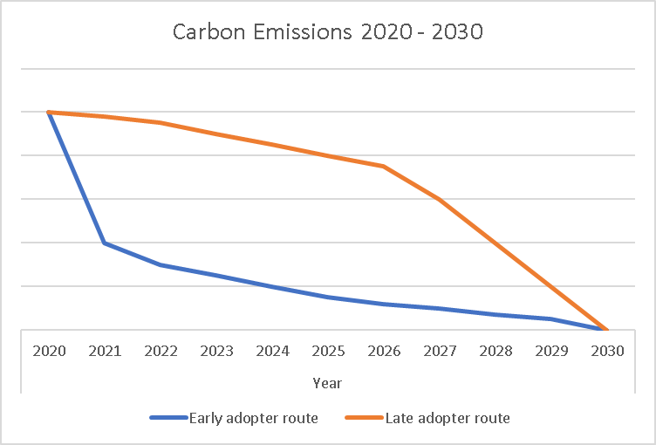

The blue line shows the early adopter method, with carbon emissions reducing substantially in the first few years. Conversely, the late adopter method (in red) shows a slower start with larger improvements towards the end of the decade. Both routes would lead the net zero result by 2030 but the final carbon footprint for the decade, the areas below the lines in the graph, is significantly less if those large improvements are made early in the decade.
Therefore, in addition to the aim of 2030 carbon neutrality we have considered those actions that will make the largest change and be ready to implement those at the earliest opportunity. This will have the result of lowering the final carbon footprint for the Borough over the course of the decade.
This approach is not fully within the gift of the Local Authority to determine. For example, a significant change will come with the retro-fitting of heating mechanisms within the existing residential dwellings of the Borough. This is likely to require national Government intervention to make it an affordable proposition for many residents. At this time we do not know if or when such a national scheme will be launched. However, as a council what we are able to do is –
Lobby national Government for the provision of assistance to property owners Ensure we are placed to apply for funding when it does become available
Look to alternative private organisations that may provide retrofitting at affordable rates
Work with residents to improve the thermal efficiency of their homes in the meantime, e.g. through loft and wall insulation
Work with colleges and businesses to ensure that if / when a mass scheme is launched, we have enough suitable qualified fitters in the region to meet local demand
Such actions would ensure that, whilst we can’t govern the date of commencement for such projects, we are in a position to commence with them at the very earliest opportunity
Once the action plan has been agreed this will be used as the basis for guidance and training for elected members and staff on integrating the climate emergency into decision- making

Our prioritisation of the climate emergency will be integrated into all induction training for elected members and staff

The strategy and action plan will be used to formulate awareness campaigns to raise awareness of mitigation measures they can put into practice in the work place or at home.
At all times the Council will seek to adopt best practice, share its knowledge and encourage others within the Borough to operate in a sustainable manner

Performance / Monitoring

Each year, the Council will calculate its carbon emissions using Scopes 1 and 2, and those areas of Scope 3 where records are available. These findings, along with improvements made and recommended actions, will be reported to elected members of the Council.
In addition, the Council will update the calculations for the Borough, showing progress over time. This will also be reported to elected members.
One Carbon World suggested that ‘to effectively monitor the carbon footprint of South Ribble Council over time, it is also recommended that a relevant performance indicator is chosen
e.g. tonnes CO2e per employee’
Achieving the targets set out in the Climate Emergency Strategy and Action Plan will be a challenge and the Council will need to be able to calculate its carbon emissions and understand the impacts of all new major plans, policies and projects.
The Climate Emergency Task Group will provide an annual update on progress against the strategy and action plan. This will also include planned improvements to the strategy based on emerging technology, external funding sources available, and the sharing of best practice.

Resources

In order to enable these actions, the Council has, in 2020, specifically reserved £250k for climate emergency actions.

References check and re-order at the end

1.Met Office. What is climate change? What is climate change? - Met Office (accessed 18th June 2021)
2.Gov.uk. Climate change explained www.gov.uk/guidance/climate-change-explained, (accessed 7th April 2020)
6.World Health Organisation. Food Safety, Climate Change and the role of WHO. https://www.who.int/foodsafety/_Climate_Change.pdf, (accessed 7th April 2020)
7.National Center for Biotechnology Information. Global warming and infectious disease https://www.ncbi.nlm.nih.gov/pubmed/16216650 (accessed 20th April 2020)
8.Met Office. UK Extreme Events – heavy rainfall and floods https://www.metoffice.gov.uk/research/climate/understanding-climate/uk-extreme-events-_heavy- rainfall-and-floods (accessed 20th April 2020)
9.Committee on Climate Change, February 2019. UK Housing: Fit for the future? https://www.theccc.org.uk/wp-content/uploads/2019/02/UK-housing-Fit-for-the-future-CCC-2019.pdf (accessed 7th April 2020)
10.British Medical Association. Air pollution and climate change https://archive.bma.org.uk/collective- voice/policy-and-research/public-and-population-health/climate-change (accessed 14th April 2020)
11.Acclimatise. Building climate resilience https://www.acclimatise.uk.com/2017/12/11/climate- change-adaptation-from-a-water-land-energy-food-climate-nexus-perspective/ (accessed 8th April 2020)
12.Freepik https://www.freepik.com/ (accessed 14th April 2020)
13.Greenhouse Gas Protocol https://ghgprotocol.org/ (accessed 8th April 2020)
14.Gov.uk. National Statistics, UK local authority and regional carbon dioxide emissions national statistics: 2005 to 2017 https://www.gov.uk/government/statistics/uk-local-authority-and-regional- carbon-dioxide-emissions-national-statistics-2005-to-2017, (accessed 8th April 2020)
15.Eurostat. Greenhouse gas emissions, base year 1990 https://ec.europa.eu/eurostat/databrowser/view/t2020_30/default/line?lang=en, (accessed 8th April 2020)
16.The Met Office. https://www.metoffice.gov.uk/weather/climate-change/what-is-climate-change, (accessed 27th April 2020)
17.IPCC http://www.climatechange2013.org/images/report/WG1AR5_SPM_FINAL.pdf (accessed 24th April 2020)
18.Centre for Aviation https://centreforaviation.com/analysis/reports/european-airline-capacity-the- deepest-cuts-slow-now-what-next-522102 (accessed 27th April 2020)
19.Gov.UK, Downing Street Briefing Presentation 30.03.2020 https://assets.publishing.service.gov.uk/government/uploads/system/uploads/attachment_data/file/ 87 6889/FINAL_Press_Conference_Slides_20200330.pdf (accessed 27th April 2020)
20.BBC News, Coronavirus lockdown sees air pollution plummet across UK
https://www.bbc.co.uk/news/uk-england-52202974 (accessed 28th April 2020)
22.Department for Business, Energy and Industrial Strategy, Future support for low carbon heat https://assets.publishing.service.gov.uk/government/uploads/system/uploads/attachment_data/file/88 1622/future-support-for-low-carbon-heat-consultation.pdf (accessed 28th April 2020)
23.World Health Organisation, Health and Sustainable Development. Climate Impacts https://www.who.int/sustainable-development/transport/health-risks/climate- impacts/en/ (accessed 29th April 2020)
24.The Met Office, UK Climate Projections :Headline Findings version 2 https://www.metoffice.gov.uk/binaries/content/assets/metofficegovuk/pdf/research/ukcp/ukcp- headline-findings-v2.pdf (accessed 6th May 2020)
25.Committee on Climate Change, Take urgent action on six key principles for a resilient recovery https://www.theccc.org.uk/2020/05/06/take-urgent-action-on-six-key-principles-for-a-resilient-recovery/
(accessed 6th May 2020)
26.The Met Office, UK Extreme events – Heavy Rainfall and Floods https://www.metoffice.gov.uk/research/climate/understanding-climate/uk-extreme-events-_heavy- rainfall-and-floods (accessed 6th May 2020)
27.The National Center for Biotechnology Information, Increased plastic pollution due to Covid-19 pandemic: Challenges and recommendations Increased plastic pollution due to COVID-19 pandemic: Challenges and recommendations (nih.gov) (Accessed 18th June 2021)
28.Department for Environment, Food and Rural Affairs, Air Quality Expert Group. Estimation of the changes in air quality pollution emissions, concentrations and exposures during the COVID-19 outbreak in the UK. https://uk-air.defra.gov.uk/assets/documents/reports/cat09/2007010844_Estimation_of_Changes_in_Air_Pollution_During_COVID-19_outbreak_in_the_UK.pdf (Accessed 18th June 2021)
29.Scatter (Setting City Areas Targets and Trajectories for Emissions Reduction) Inventory Summary (scattercities.com) (Accessed 18th June 2021)

Glossary

BEIS – The department for Business, Energy and Industrial Strategy
Biodiversity – The variety of animal and plant life on Earth
Carbon budget – the amount of carbon dioxide that can be emitted to be in line with keeping temperatures well below 2 oC and pursue a 1.5oC limit to rising temperatures
Carbon dioxide – a key greenhouse gas with a long life-time in the atmosphere.
Carbon neutral – having no net release of carbon dioxide into the environment. Carbon Neutral may be used as short hand for Net Zero Greenhouse Gas emissions, taking into account our direct emissions in the city from energy use and transport but also our total indirect emissions which includes aviation and the consumption of goods and service produced elsewhere.
CO2e - this stands for carbon dioxide equivalent. This allows the comparison and inclusion of other GHGs (e.g. nitrous oxide and methane) as well as carbon dioxide. It represents the corresponding amount of carbon dioxide that would be required to produce the same level of warming as other GHGs.
Carbon offsetting – practices to neutralise remaining emissions that cannot be removed entirely
CIEH – Chartered Institute of Environmental Health
Decarbonisation - Reducing the carbon emissions from an energy system.
DEFRA - Department for Environment, Food and Rural Affairs
Direct Emissions - Direct emissions refers to Scope 1 and 2 emissions in the Greenhouse Gas Emissions Protocol and include the Council’s use of gas, electricity, transport fuel and water.
EA – Environment Agency
FSA – Food Standards Agency
GHG – Greenhouse gases are those gaseous constituents of the atmosphere, which absorb and emit radiation at specific wavelengths within the spectrum of thermal infrared radiation emitted by the Earth’s surface, by the atmosphere itself, and by clouds. This property causes the greenhouse effect. Water vapor (H2O), carbon dioxide (CO2), nitrous oxide (N2O), methane (CH4), and ozone (O3) are the primary greenhouse gases in the Earth’s atmosphere. Moreover, there are a number of entirely human-made greenhouse gases in the atmosphere, such as the halocarbons and other chlorine- and bromine containing substances, dealt with under the Montreal Protocol. Besides CO2, N2O, and CH4, the Kyoto Protocol deals with the greenhouse gases sulphur hexafluoride (SF6), hydrofluorocarbons (HFCs), and perfluorocarbons (PFCs). (IPPC)
Greenhouse effect - Greenhouse gases effectively absorb thermal infrared radiation, emitted by the Earth’s surface, by the atmosphere itself due to the same gases, and by clouds. atmospheric radiation is emitted to all sides, including downward to the Earth’s surface. Thus, greenhouse gases trap heat within the surface-troposphere system. This is called the greenhouse effect. (IPPC)
Global warming – an increase in combined surface, air and sea temperatures averaged over the globe and over a 30-year period (IPPC)
IPCC – Intergovernmental Panel on Climate Change, the United nations body for assessing the science relating to climate change
Kyoto Protocol – this commits industrialised countries to limit and reduce GHG emissions based upon the 1990 levels. (United Nations)
LCC – Lancashire County Council
NOx – term for the nitrogen oxides that are most relevant for air pollution, namely nitric oxide and nitrogen dioxide. NOx gases react to form smog and acid rain as well as being central to the formation of fine particles (PM) and ground level ozone, both of which are associated with adverse health effects.
Offsetting - Carbon offsetting refers to the purchase of a tradeable unit, representing emissions rights or emissions reductions, to balance the climate impact of an organisation, activity or individual. Although they can be stored
PHE – Public Health England
PM – particulate matter. Particulate matter is formed in the atmosphere because of chemical reactions between pollutants. These particles include dust, dirt, soot, smoke, and liquid droplets. Particulate matter is in the air pollution emitted from vehicles, factories, and burning of fossil fuels
PM2.5 – particulate matter with a diameter equal to or less than 2.5 micrometres also known as fine particulate matter. Long term exposure is understood to increase mortality risk, particularly from cardiovascular causes.
Scope 1 emissions– direct GHG emissions – these occur from sources that are owned or controlled by the company, for example, emissions from combustion in owned or controlled boilers, furnaces, vehicles, etc.; emissions from chemical production in owned or controlled process equipment (Greenhouse Gas Protocol.org). They are mainly energy related.
Scope 2 emissions– Electricity indirect GHG emissions – this accounts for GHG emissions from the generation of purchased electricity consumed by the company. Purchased electricity is defined as electricity that is purchased or otherwise brought into the organisational boundary of the company. Scope 2 emissions physically occur at the facility where electricity is generated. (Greenhouse Gas Protocol.org).
Scope 3 emissions – all other greenhouse gas emissions that occur as a result of activities taking place within wider operations, supply chains, investments, etc.
Sequestration - the uptake of carbon-containing substances, in particular carbon dioxide from the atmosphere.
Solare PV – Solar Photovoltaic
SRBC – South Ribble Borough Council
Sustainability – meeting the needs of current generations, without compromising future generations or the environment
Vector - Vectors are mosquitoes, ticks, and fleas that spread diseases. A person who gets bitten by a vector and gets sick has a vector-borne disease.
VOC – volatile organic compound, a chemical that changes easily into a gas and can be harmful to health and the environment
WHO – World Health Organisation

Appendices

Appendix 1 - SRBC climate emergency task group scope

Scoping Sheet

Title of Working Group: | Climate Emergency Working Group
Type of Working Group: | Cross-party Member Working Group reporting to Council
Task Group Members: | - Councillor Keith Martin (Chair)  - Councillor Stephen Thurlbourn (Vice-Chair)  - Councillor Susan Jones  - Councillor Jane Bell  - Councillor Chris Lomax  - Councillor Colin Coulton  - Councillor Michael Green  - Councillor Peter Mullineaux  - Councillor Matthew Trafford  - Councillor Angie Turner
Officer Support | - Jennifer Mullin  - Neil Martin  - Melanie Berry  - Coral Astbury
Rationale | - In 2018, the Intergovernmental Panel on Climate Change (IPCC) published a report which advised that we must limit global warming to 1.5°C, as opposed to the previous target of 2°C. Their review of over 6,000 sources of evidence found that, with a rise of 1.5°C, there would be risks to health, livelihoods, food security, water supply, human security and economic growth.  - It is recognised by the majority of scientists and governments that climate change is occurring and without significant action to address the problem and limit carbon *emissions serious life threatening consequences will occur.  *This scoping sheet refers to emissions of ‘carbon’ or ‘carbon dioxide’. This should be considered shorthand for all greenhouse gas emissions, not just carbon dioxide.  - In July 2019 Full Council passed a motion which declared a Climate Emergency with the overarching goal of “rendering the borough carbon neutral by the year 2030”.  - This goal means the borough shall produce no net carbon emissions by this date, taking account of actions that have the effect of removing carbon from the environment.  - The Group recognises that there are other factors beyond its control that would help to tackle a worldwide reduction of carbon.  - Following this declaration, a cross party working group was therefore created to form an Action Plan to achieve this goal and report back to Council detailing the proposed scope of the review and actions.
Review Aims & Objectives:  Please include the main priorities of the project, etc. | Aim:  To achieve carbon neutrality for the borough of South Ribble by 2030, taking account of any carbon offsetting identified.  Objectives:  - To carry out an assessment of current activities, including estimating the current Carbon Footprint of South Ribble.  - To research best practice and look for innovative new approaches to reducing carbon emissions, carbon off setting and climate mitigation.  - To produce a Climate Emergency Strategy and way forward for Council to consider.  - To include those elements contained within the Greenhouse Gas Protocol defined as Scope 1 and Scope 2 emissions. Direct emissions shall be taken as including fuel (energy), vehicles, farming, quarrying, waste produced and deposited within the borough from Domestic, Commercial, Industrial, Educational, Farming and leisure activities. It does not include those emissions generated by vehicles travelling through the borough, i.e. on motorways or by railway.  - To define all emissions and reductions against a base year of 1990.
In Scope: | - Consultation  - Community engagement  - Working with external partners such as One Carbon World who are partnered with the UN Climate Neutral Now Initiative.  - Work with partners across the district, county and region to help deliver this new goal through all relevant strategies, plans and shared resources.  - Lobby Government on issues that the Council do not have any direct control over to reduce carbon emissions e.g. transport, agriculture, industry and housing.  - Influence Local Plan and Central Lancashire Strategy by working toward developing policies that reduce carbon emissions.  - Work with young people, including in schools and Colleges.  - To use the Council’s direct areas of wider influence. These are areas where the Council can have a significant impact on reducing wider carbon emissions and mitigating climate in the District- Housing, planning / building control, tree planting.  - To become a climate Change leader for the borough. The Council does not have any direct control over significant causes of emissions egg transport, agriculture, industry and housing. However, we can adopt a leadership role and engage with, influence, support mitigation of climate change across the whole District.  - To investigate, promote and as required implement measures to help mitigate against the impacts of climate change (heatwaves, cold spells, drought, pests).
Link with Corporate / Divisional / Service Aims and Priorities: | The review links directly with our new council vision:  ‘A healthy and happy community, flourishing together in a safer and fairer borough’  There are also links with all our new priorities:  - Health, wellbeing and safety  - Our people and communities  - Place homes and environment
Indicators of Success: | - The review meets its objectives and produces a comprehensive Climate Emergency Strategy with SMART (specific, measurable, achievable, and realistic and timebound) recommendations.
Methodology/Approach | - Audit of existing Carbon Footprint of the borough  - Desktop review of best practice  - Visit best practice authorities  - Sign up to One Carbon World  - Inviting Climate Experts  - All Member Workshop  - Worksop with partners  - Workshop with staff  - Identifying funding options available  - Residents’ Survey
Witnesses/Experts/Interested Parties | - One Carbon World  - Academic Experts  - Association of Head Teachers in South Ribble  - Young people  (others as deemed appropriate)  Invitation to attend meetings of the Climate Emergency Working Group will be agreed in advance by members of the Group.
Evidence Sources for Documents | - Department of Environment, Food and Rural affairs.  - Local Government Association  - Ministry of Housing, Communities & Local Government  - Forestry Commission  - APSE Local Government Network  - Other relevant interested groups, organisation and experts  - (this list is not exhaustible)
Site Visits | - Environment Conferences  - Best Practice Authorities
Publicity Requirements | - Website including Social Media  - Councillor Ward Surgeries  - Public Drop-in sessions  - Public Consultation on draft Climate Emergency Strategy  - Letters to stakeholders/interested parties  - Article on Cllr Connect  - Article on Employee Connect  - Ad-hoc Press Releases throughout process.  - Advertising  - Local Radio  - My neighbourhood forums
Other Resources Requirements:  Including financial | To be met from existing budgets (currently).
Review implications / impacts / risks:  Consider financial, planning, social, economic, environmental, health and safety, legal, service provision, procurement etc. | - Close working of the Member Task Group  - Ensure there is no duplication of work  - Ensure we get member, employee and partners buy-in and support  - Ensure the project remains within scope  - Ensure the project remains to timescale  - Six-monthly monitoring of the implementation of recommendations
Milestones during Implementation: | - Update report to Cabinet early 2020  - Update full Council 4 times a year.  - Produce Climate Emergency Strategy Outline by June 2020  - Finalise Climate Emergency Strategy by September 2020
Project Monitoring Arrangements: | - To be monitored at the regular members meetings.
Cover Sheet Completed by:  (Name and Signature) |  | Date
Project Approved by:  (Name and Signature) |  | Date:

Appendix 2 - SRBC Notice of motion July 2019

(The Notice of Motion is an exert from the Agenda and Minutes of Council meeting, 24th July 2019 – all full copy of the agenda and minutes is available at https://southribble.moderngov.co.uk/ieListDocuments.aspx?CId=134&MId=1471&Ver=4 )
Notice of Motion
Notice of the following motion has been submitted in accordance with standing order number 10(2). The motion is proposed by Councillor Ken Jones and seconded by Councillor Matthew Trafford.
“This Council declares that the effect of climate change within the borough poses an immediate danger to the health and well-being of our residents and therefore proclaims a Climate Emergency with immediate effect.
To combat this threat, the borough sets a goal of rendering the borough carbon neutral by the year 2030. For avoidance of doubt, this goal means the borough shall produce no net carbon emissions by this date, taking into account of actions that have the effect of removing carbon from the environment.
In order to implement this decision, the borough shall create a Standing Working Group on the Climate Emergency. The Group shall be made up of the following:
Cabinet Member responsible for the Environment (in the Chair);
Chairs of each Neighbourhood Forum;
Representatives of each political group represented on the council (2 Labour Members (including Air Quality Lead), 1 Liberal Democrat Member. 2 Conservative Members);
Air Quality Lead;
Such other Members, including co-opted members, as the working group shall consider appropriate.

The Standing Working Group on the Climate Emergency shall:
Incorporate the Council’s existing Air Quality Action Plan into its wider plans;
Devise and propose further measures in pursuit of its goals;
Monitor progress towards its goals;
Report back to full Council at least four times per year on its progress in achieving its goals.

The standing Working Group on Climate Emergency shall be resourced through the Council’s annual budgets going forward.”

Minutes:
The motion was moved by Councillor Ken Jones, seconded by Councillor Matthew Trafford. Councillor Jones delivered a presentation on the effect that climate change was having on the world.
The Motion stated:
“Climate Emergency
This Council declares that the effect of climate change within the borough poses an immediate danger to the health and well-being of our residents and therefore proclaims a Climate Emergency with immediate effect.
To combat this threat, the borough sets a goal of rendering the borough carbon neutral by the year 2030. For avoidance of doubt, this goal means the borough shall produce no net carbon emissions by this date, taking into account of actions that have the effect of removing carbon from the environment.

In order to implement this decision, the borough shall create a Standing Working Group on the Climate Emergency. The Group shall be made up of the following:
Cabinet Member responsible for the Environment (in the Chair);
Chairs of each Neighbourhood Forum;
Representatives of each political group represented on the council (2 Labour Members (including Air Quality Lead), 1 Liberal Democrat Member. 2 Conservative Members);
Air Quality Lead;
Such other Members, including co-opted members, as the working group shall consider appropriate.

The Standing Working Group on the Climate Emergency shall:
Incorporate the Council’s existing Air Quality Action Plan into its wider plans;
Devise and propose further measures in pursuit of its goals;
Monitor progress towards its goals;
Report back to full Council at least four times per year on its progress in achieving its goals.

The standing Working Group on Climate Emergency shall be resourced through the Council’s annual budgets going forward.”
The motion was debated across the Chamber, with Councillors, David Howarth, Keith Martin, Paul Foster, Mick Titherington, Matthew Tomlinson and Matthew Trafford speaking in favour. Although an ambitious target, Members felt that they owed it to the residents to look into this issue as a matter of urgency and held a strong belief that they could bring about change.

An amendment to the motion was proposed by Councillor Caroline Moon, and seconded by Councillor Michael Green. Along with some minor changes to wording and a reduction in the membership of the Standing Working Group, the amendment sought to extend the goal of rending the bough carbon neutral to 2050 in line with central government targets.

Whilst being in support of the motion and the Council’s ambition to take a lead, Councillor Alan Ogilvie spoke in support of the amendment, as he felt the 2030 target was to ambitious and over promised on what could realistically be achieved by this authority.

Upon being put to the vote, the amendment was LOST (Yes: 16, Abstention: 1, No: 26)

The vote on the substantive motion was then taken and was subsequently RESOLVED (Yes: 30, Abstention: 13, No: 0). The motion was CARRIED.

Appendix 3 - Revised One Carbon World Report for the period 2018 - 2019

Insert on receipt

Appendix 4 – Annual greenhouse Gas Report to end March 2021

- Introduction
In 2019 South Ribble Borough Council declared a climate emergency, committing the Borough to becoming carbon net zero by 2030.

Within the borough, the Council Organisation has an important role, as a major employer, significant energy user and community leader to lead by example in reducing its own corporate carbon emissions.

This report provides an annual overview of Greenhouse Gas (GHG) emissions from the Council’s estate and operations to the end of March 2021. The GHG emissions have been calculated using guidance and emissions factors published by the department for Business, Energy and Industrial Strategy (BEIS). Where UK data and emissions factors are not yet available the Council has estimated carbon emissions using the methodology of One Carbon World, as used for the first detailed carbon footprint calculations for the period of 2018/19. The links to this source material are provided as references below.

- Results
The table below provides an overview of the Greenhouse Gas emissions over the last three financial years. Water usage, wastewater and business mileage have been included within the last two years as data has become available.
Table 1 – GHG emissions reported as kilograms of carbon dioxide equivalent (kg CO₂e).

 | 2018/2019 | 2019/2020 | 2020/2021
Scope 1
Natural Gas | 218,422.70 | 199,093.47 | 143,663.47
Petrol for SRBC vehicles | 10,694.30 | 12,445.73 | 12,537.66
Diesel for SRBC vehicles | 714,557.63 | 1,326,358.07 | 1,370,161.32
Gas oil / Red diesel | 70,091.68 | 67,634.07 | 66,018.02
Other, including lubricants, weed killer, antifreeze, etc. | 20,469.79 | 35,363.24 | 32,226.52
Scope 2
Electricity | 117,441.21 | 197,654.71 | 134,636.72
Scope 3
Electrical transmission and distribution | 28,913.27 | 46,691.67 | 34,040.32
Business travel | Not included | 32,515.00 | 15,181.15
Water supply | Not included | 5,285.51 | 3,005.92
Wastewater | Not included | 10,865.68 | 6,179.42
Other, including material use, waste disposal and well to tank * calculations for all fuels | 605,890.96 | 710,544.60 | 632,529.00
Total gross emissions | 1,786,481.53 | 2,644,451.72 | 2,450,179.48
Carbon off-setting | 300 tonnes from One Carbon World | - | -
Total annual net emissions | 1,786,181.53 | 2,644,451.72 | 2,450,179.48
Intensity measurement (kg  CO2e per  No. FTE employees)** | 6,603.26 | 9,794.27 | 8,291.64
Intensity measurement (kg  CO2e per  Total number Employees)** | 5,894.99 | 8,800.17 | 7,470.06
*Well to tank is the energy usage in the fuel supply chain, ahead of the fuel being utilised by the Council (including extraction, refining and transportation of primary fuels)
**Those staff employed in a shared service arrangement with Chorley Borough Council are classed as 0.5 of a post for the purposes of these calculations.
Figure 1 – Graph showing annual changes in emissions

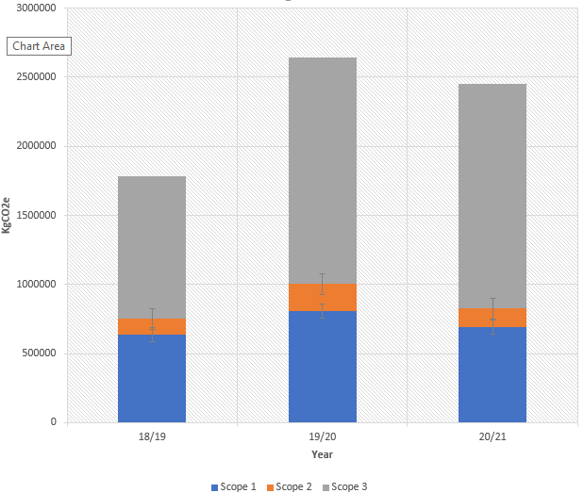
Note – Years 19/20 and 20/21 also include staff travel, water consumption and wastewater within the Scope 3 emissions

Table 2 – South Ribble Borough Council’s operational scopes

Scope 1  (direct) | Scope 2  (energy) | Scope 3  (other indirect)
Gas and oil used for heating Council operated buildings (not tenanted buildings) | Electricity consumption within operated Council Buildings (not tenanted buildings) | Employee business travel
Fuel consumption from SRBC fleet vehicles |  | Electrical transmission and distribution
Chemical use such as anti-freeze, weed killer, Ad Blue, engine oil, etc. |  | Waste disposal
 |  | Water consumption (from April 2019)
 |  | Wastewater (from April 2019)
Excluding | Excluding | Excluding
Refrigerant emissions from air conditioning and other equipment |  | Some material use and disposal, including items such as books, tyres, clothing / uniforms, and electrical items
 |  | Employee and elected member commuting

- Supporting Information
3.1 Organisation Information
South Ribble Borough Council is responsible for providing a wide range of services to residents of the Borough, those visiting the Borough and to businesses operating within the Borough.
The Council serves a population of approximately 110,00 and has approximately 328 employees, either employed solely by SBRC or in a shared service agreement with Chorley Borough Council.
The carbon footprint boundary includes those activities under the operational control of the Council, under Scopes 1,2 and 3 of the Greenhouse Gas protocol.

3.2 Reporting Period
For the period 2018/2019 One Carbon World calculated the annual GHG emission report for the Council
For the periods 2019/2020 and 2020/2021 the Council has undertaken these assessments internally, using the methodology and data provided by the department for Business, Energy and Industrial Strategy. Where this data does not provide for activities undertaken by the Council (for example the use of engine oil and weed killer) then these have been estimated using the data and methodology of One Carbon World. As the UK provides for the calculation of emissions from such goods, the Council will transfer to the use of the UK methodology and data.

3.3 Operational Scope
This report includes Scope 1, 2, and 3 emissions.
Scope 1 emissions are direct emissions resulting from the Council’s activities, including the use of fuels and chemicals.
Scope 2 emissions are indirect emissions, associated with the use of electricity. These indirect emissions arise as a result of the Council’s electricity consumption, but the emissions occur at sources not owned or controlled by the Council.
The Scope 1 and Scope 2 emissions have been measured for all properties and vehicles that the Council owns and controls. Those buildings within the Council estate that are rented out have been excluded from the scopes.
Scope 3 emissions are other indirect emissions, where the choices and actions of the Council result in emissions occurring at sources not owned or controlled by the Council, for example consumption of goods and waste disposal.
Scope 3 emissions are reported, based on the availability of comprehensive and reliable data. The Council will continue to improve the capture of GHG emissions data, which will allow for future enhanced reporting of Scope 3 emissions. For example, the original calculation for 2018/2019 did not include staff travel, water use and wastewater. These have been added from April 2020 to more accurately reflect the full range of activities and fuel usage.
In April 2021 the Council’s leisure services transferred back to Council control from a partner organisation. Therefore, from April 2021 our emissions calculations will also include these leisure services and their staff. These facilities also use significant amounts of water and energy through their operations.
The activities / emissions included within these calculations are:
- Fuels
- Material use
- Transmission and Distribution
- UK electricity
- Water use and water disposal
- Other waste disposal
- Additional factors (WTT – well to tank related emissions) for fuels and electricity
Links to the precise methodology and data utilised are provided as references below, but as a guide the Greenhouse Gas equivalent (CO₂e) emissions are calculated by multiplying the resources used during the reporting year by the relevant emissions factor for that year.

SRBC annual data x emission factor = Greenhouse Gas emissions
All conversion factors used in this report are in units of kilograms of carbon dioxide equivalent (kg CO₂e).

3.4 Assumptions and / or Omissions
To maintain consistency of reporting the same assumptions are used in each of the accounting periods -
Emissions from waste production have been calculated over a 52-week period and using
0.5 tonnnes weight for a full 1,100 litre bin and 15 tonnes per 20yd ro-ro skip.
Emissions from use of lubricant and hydraulic oils based on assumption that 1,149 litres weigh 1 tonne (https://www.quora.com/How-many-litres-of-oil-will-make-one-tonne-oil).
Emissions from use of organic compost based on 700 litres = 1 tonne.

3.5 Limitations of Assessment
Presently, gas and electricity are measured as a whole for the entire estate. In order to better understand our consumption and evidence the effect of future heat decarbonisation plans, it is intended that from April 2021 future GHG emissions reports will include specific calculations relating to the use of energy at the Council’s largest energy using buildings –
- Civic Centre, Leyland
- Moss Side Depot, Leyland
- Leyland Leisure Centre
- Penwortham Leisure Centre
- Bamber Bridge Leisure Centre
- South Ribble Tennis and Fitness Centre

3.6 Carbon offsetting
The Council has not committed to the use of carbon offsetting, prioritising instead carbon reduction measures. No quantifiable carbon off-setting measures have been utilised.

- Changes in Emissions
4.1 Scope 1, 2 and 3 Emissions
When One Carbon World was employed to calculate the GHG emissions for the Council’s activities for 2018-2019, the resulting report made the following recommendations:
‘The amount of natural gas used is reviewed and if possible reduced. As natural gas is primarily used for heating purposes, there could be some very quick wins with a thorough audit of the system. On the back of the audit and identification of energy use over time, there could be better/more efficient methods to insulate Council buildings, improve heating systems, or supply alternative/renewable energy sources for heating, e.g. infrared panel heaters, air source heat pumps (ASHPs), ground source heat pumps (GSHPs), solar thermal, solar PV plus others.’
In 2020, the Council was awarded a Public Sector Decarbonisation grant of £145,004. This will provide heat decarbonisation measures at the Civic Centre, Leyland including the installation of further solar PV panels, the installation of LED lighting, and the provision of an improved building management system, to allow for better energy control and efficiency within the building.
In addition the Council is undertaking energy audits at 6 of it’s largest energy using buildings (Civic Centre, Moss Side Depot, Leyland Leisure Centre, Penwortham Leisure Centre, Bamber Bridge Leisure Centre and South Ribble Tennis and Fitness Centre) to determine those heat decarbonisation measures possible and provide an estimation of costs. This will include consideration of the building management systems on site and potential improvements.
‘The amount of diesel/petrol used is reviewed and if possible reduced. On the back of a thorough audit and identification of diesel/petrol use over time, better/more efficient use of vehicles can be achieved through planning to reduce journey numbers. Also, more and more hybrid and electric vehicles are available in the marketplace with much lower emissions. By phasing out over time vehicles that run on diesel/petrol and replacing them with vehicles that use hybrid technology or that are electric powered, South Ribble Council will be able to reduce the carbon footprint of its operations (and potentially reduce fuel costs).’
As part of the Green Agenda Project the Council is to undertake an audit of all corporate travel, including our own fleet.
The Council has a rolling programme to replace end of life fleet vehicles with electric vehicles, where technology allows.

‘To effectively monitor the Carbon Footprint of South Ribble Council over time, it is also recommended that a relevant performance indicator is chosen e.g. tonnes CO₂e per Employee.

4305.41 tonnes CO2e / 250 employees = 17.22 tonnes of CO2e per person per year.
Other performance indicators could also be used, such as those based on financial data
e.g. KgCO₂e per £, with the cost indicator linked to financial turnover and/or profit.’

This has been implemented as part of the data provided within Table 1 of the report, with both options of total number of employees and full time equvialents (FTE) provided to allow representative benchmarking

4.2 Carbon Emission Factors
These are revised and published on an annual basis, for the calendar year. The annual Greenhouse Gas emissions depend not only on the resources used by the Council, but the national emission conversion factors, which may change annually.

4.3 Intensity Measurement
We have taken the approach of measuring the Council’s emissions per total number employees, and also per full time employee equivalent so we are able to benchmark against other organisations, to learn from best practice and help others in making improvements within their own organisations.
Those employees classed as shared service employees with Chorley Borough Council will be classed as 50% SRBC employees, 50% Chorley Borough Council employees for the purposes of the GHG emissions calculations.

- References
Greenhouse gas protocol: Corporate accounting and reporting standard, (online) available from https://ghgprotocol.org/corporate-standard (accessed 18 May 2021)
Greenhouse gas reporting: conversion factors 2018, (online) available from Greenhouse gas reporting: conversion factors 2018 - GOV.UK (www.gov.uk) (accessed 19 May 2021)
Greenhouse gas reporting: conversion factors 2019, (online) available from Greenhouse gas reporting: conversion factors 2019 - GOV.UK (www.gov.uk) (accessed 19 May 2021)
Greenhouse gas reporting: conversion factors 2020, (online) available from Greenhouse gas reporting: conversion factors 2020 - GOV.UK (www.gov.uk) (accessed 19 May 2021)

- Glossary
BEIS - Department for Business, Energy and Industrial Strategy
Carbon neutral – having no net release of carbon dioxide into the environment
Carbon offsetting – practices to neutralise remaining emissions that cannot be removed entirely
CO₂e - the universal unit of measurement to indicate the global warming potential (GWP) of GHGs, expressed in terms of the GWP of one unit of CO₂.
DEFRA - Department for Environment, Food and Rural Affairs
GHG – greenhouse gases - There are seven main GHGs that contribute to climate change, as covered by the Kyoto Protocol: carbon dioxide (CO₂), methane (CH₄), nitrous oxide (N₂O), hydrofluorocarbons (HFCs), perfluorocarbons (PFCs), sulfur hexafluoride (SF₆) and nitrogen trifluoride (NF₃).

Appendix 5 – Actions arising from the Air Quality Action Plan 2018

Action | Broad Topic Area | Lead Authority/Department
To publicise and encourage the use of the Lancashire based Air Quality Guidance Document for Developers. | Planning – policy / development control | SRBC – Environmental Health / Planning
To include the above air quality guidance document within the revised Central Lancashire Core Strategy | Planning - policy | SRBC - Planning
To develop and embed a low emission strategy into planning decisions | Planning – policy / development control | SRBC – Planning / Environmental Health
To require a suitable air quality assessment in line with a published Air Quality Guidance Document for Developers for all planning applications as identified within the document | Planning – development control | SRBC – Planning / Environmental Health
Develop an ‘Electric Vehicle Charging Points Guidance for Development’ guidance document and have this included within the revised Central Lancashire Core Strategy | Planning - policy | SRBC – Environmental Health
Ensure adequate Electrical Vehicle charging infrastructure is provided on all Planning Applications in line with the Council’s Electric Vehicle Charging Points Guidance for Developments | Planning – development control | SRBC - Planning
Require suitable travel plans to be produced, and implemented on all relevant developments in line with the low emissions strategy | Planning – development control | SRBC - Planning
Require secure cycle storage to be included on all relevant domestic, commercial, industrial, and leisure developments | Planning – development control | SRBC - Planning
Action | Broad Topic Area | Lead Authority/Department
Require adequate changing facilities to be provided for use of staff / visitors for all relevant commercial and industrial developments | Planning – development control | SRBC - Planning
Promotion of living walls / green roofs | Planning | SRBC – Planning / Environmental Health
Investigate ways to limit the use of solid fuel heating in developments | Planning | SRBC – Planning / Environmental Health
Improved Planning enforcement | Planning | SRBC – Planning / Environmental Health
Securing four major road developments identified within the Lancashire County Council ‘Central Lancashire Highways and Transport Masterplan’ | Infrastructure | Lancashire County Council – City Deal / Highways
To review all traffic light sequencing to reduce the amount of standing traffic | Infrastructure | Lancashire County Council – Highways, with input from SRBC – Environmental Health
To investigate the provision of a link road between Centurion Way and Tomlinson Road | Infrastructure | SRBC - Planning / Environmental Health
Consider road layouts within the AQMA’s to see whether improvements can be made to reduce congestion | Infrastructure | SRBC – Environmental Health  Lancashire County Council – Highways
Look to improve signage to re-direct HGV traffic away from areas of poor air quality | Infrastructure | Lancashire County Council – Highways
Action | Broad Topic Area | Lead Authority/Department
Work with Highways England to improve signage to the motorways to advise HGV’s to use Junction 29 instead of junction28 | Infrastructure | Highways Agency  SRBC – Environmental Health
Provide advice and contacts to businesses to help them chose low emission vehicles, & develop travel plans | Infrastructure | SRBC - Environmental Health  Lancashire County Council – Highways
Improve the cycle infrastructure within the borough, especially along routes to schools and employment sites | Infrastructure | Lancashire County Council – Highways
Maintain & Sweep cycle routes on a regular basis throughout the borough | Infrastructure | Lancashire County Council – Highways  SRBC - Neighbourhoods
Improve the electric vehicle infrastructure across the borough | Infrastructure | Lancashire County Council  SRBC
Provide electric vehicle charging points on council owned car parks and buildings | Infrastructure | SRBC – Car parking
Offer free or reduced parting tariffs for electric vehicles | Infrastructure | SRBC – Car Parking
Anti-Idling Campaign in declared AQMA’s and outside schools, colleges and leisure centres | Infrastructure | SRBC – Environmental Health  Schools, Colleges
Encourage the greater use of public Transport | Buses & Taxis | SRBC -
Work with taxi firms to encourage the uptake of low emission vehicles (Electric) | Buses & Taxis | SRBC – Licensing / Environmental Health
Further reduce the age limit of taxis within the borough | Buses & Taxis | SRBC – Licensing / Environmental Health
Action | Broad Topic Area | Lead Authority/Department
Stop taxis and buses idling within AQMA’s and outside schools & Colleges | Buses & Taxis | SRBC – Licensing / Environmental Health  Lancashire County Council - Highways
To consider a reduced taxi license fee for electric vehicles | Buses & Taxis | SRBC – Licensing / Environmental Health
To work with both bus and taxi companies to apply for any grant bids available | Buses & Taxis | SRBC – Licensing / Environmental Health  Public Health Lancashire
Implement an ‘Electrify campaign – encouraging businesses to only use electric taxis | Buses & Taxis | SRBC – Environmental Health
Encouraging Car Sharing within the borough | Travel Choice & Education | SRBC – Environmental Health  Lancashire County Council  Public Health Lancashire
Development and delivery of education programmes to schools | Travel Choice & Education | SRBC – Environmental Health  Schools, Colleges
Development of educational material for businesses | Travel Choice & Education | SRBC – Environmental Health / Economic Development
Development and run a campaign to reduce school traffic e.g. walk/cycle to school | Travel Choice & Education | SRBC – Environmental Health  Schools, Colleges
Investigate the provision of personal travel plans for residents and employees within the borough | Travel Choice & Education | SRBC – Environmental Health
Promote cycling within the borough, including cycle to work day, salary sacrifice scheme | Travel Choice & Education | SRBC – Environmental Health / Sports Development
Promote walking within the borough, including promotion of walking routes, the Leyland Loop | Travel Choice & Education | SRBC – Environmental Health / Community
Action | Broad Topic Area | Lead Authority/Department
Encourage ‘walk to school’ and the use of ‘walking buses’ across the borough for all schools | Travel Choice & Education | SRBC – Environmental Health / sports development  Schools, Colleges
Encourage elected members to car share and use alternative forms of transport, in particular to council meetings and functions | Internal to SRBC | SRBC – Leader, Leader of the opposition
Replace the mayoral car with an electric car | Internal to SRBC | SRBC – Neighbourhood Services / Members
Provide education and information relating to air quality through members learning hours, leaflets and councillor connect | Internal to SRBC | SRBC – Environmental Health
Air Quality shall be considered within the decision making process on every report to cabinet, council, portfolio holder decision etc | Internal to SRBC | SRBC – Democratic Services / Environmental Health
Replace the civic centre pool car with an electric car | Internal to SRBC | SRBC - Neighbourhoods
Systematically replace the depot vans with electric vehicles | Internal to SRBC | SRBC - Neighbourhoods
Systematically replace grounds vehicles with electric vehicles as technology becomes available | Internal to SRBC | SRBC - Neighbourhoods
The provision of electric vehicle charging points at council buildings, initially the civic centre and depot. These may be provided free of charge to enable the installation of cheaper charging points and encourage the uptake of electric vehicles | Internal to SRBC | SRBC – Neighbourhoods / Property Services
Apply for the Workplace EVR point Government scheme | Internal to SRBC | SRBC - Neighbourhoods
Action | Broad Topic Area | Lead Authority/Department
Sign up to the nhs fleet solutions salary sacrifice scheme’ this allows staff to purchase via salary sacrifice a new car (to be restricted to electric vehicles only) including all insurance, tax, and servicing | Internal to SRBC | SRBC – Human Resources / Environmental Health
Provide secure lockable cycle storage facilities at the civic and depot | Internal to SRBC | SRBC - Neighbourhoods
Provide suitable changing rooms and storage facilities for use of staff | Internal to SRBC | SRBC – Neighbourhoods / Property Services
Continue with the ‘bike to work’ salary sacrifice scheme | Internal to SRBC | SRBC – Human Resources
Provide cycle reassurance training for any member of staff, elected members who wish to receive it | Internal to SRBC | SRBC – Sports Development
Encourage staff to use alternative modes of travel e.g. cycling and walking | Internal to SRBC | SRBC – Comms
Promote car sharing among staff | Internal to SRBC | SRBC - Comms
Alter the policy to allow essential users to leave their cars at home and walk/cycle to work on certain days in line with business requirements and manager agreement without the risk of loss of the lump sum | Internal to SRBC | SRBC – Extended leadership Team
Develop an internal travel plan and offer individual travel planning guidance to staff and elected members | Internal to SRBC | SRBC – Environmental Health

